Carmen Van den Bergh

Balla, Giacomo (1871—1958)
Giacomo Balla was an Italian painter and an important exponent of futurism. He began his career as a self-taught artist inheriting the passion for photography from his father, an industrial chemist as well as an amateur photographer. During his stays in Turin, Rome and Paris, Balla gained experience at various academies and inspired many young people eager for modernity, including Boccioni and Severini.

Until the first decade of the twentieth century he painted in the tradition of romantic realism, then Italian divisionism before joining the futurist adventure. From 1910 onwards he put his name under several futurist Manifestos and became one of the first abstract artists in Europe. His most successful and famous paintings belong to the time span between 1912 and 1916, marked by the search for the dynamism propagated by futurism, which he interpreted literally in the well-known painting Cagnetta al guinzaglio (Dynamism of a Dog on a Leash), where the movements of the animal and his master appear as multiplied steps, in accordance with the photographic and cinematographic principle of the persistence of vision. Another means he used to suggest the sensation of motion and light was the use of triangles, circles, lines and spirals, also called “Compenetrazioni iridescenti”.
In his manifesto The Futurist Reconstruction of the Universe (March 11, 1915), he sought, together with Fortunato Depero, to mimic the shapes of the natural world in materials such as cardboard and wood with bright colors to make it more cheerful. Fascinated by these ideas, Balla decided to name his daughters Elica (Propeller) and Luce (Light).
Balla also dealt with furniture and decoration (the pub Bal Tic-Tac in Rome), design (the futurist Suit), photography, cinema and scenography (the Fireworks ballet with music by Stravinsky), always in his personal style: colorful, imaginative and full of rhythm.
In the 1930s Balla continued in a futurist mode, even after everyone else had abandoned it. He became the fascist artist par excellence, acclaimed by critics. At the end of the decade Balla formally broke with the futurism, which placed him at the margins of the official culture until the post-war re-evaluation of his works and of futurism in general.

References and further reading

- Crispolti, E. & Drudi Gambillo, M. (1963), Giacomo Balla, 1963 (catalogo della mostra alla Galleria civica d'arte moderna, Torino, con ampia bibliografia, pp. 155-172)
- Fagiolo dell’Arco, M. (1968), Compenetrazioni iridescenti, Rome: Mario Bulzoni
- Fagiolo Dell'Arco, M. (1988), Balla: The futurist , New York: Rizzoli
- Giovanni Lista, 2009, Giacomo Balla: futurismo e neo futurismo, Milan: Mudima
- Balla, G. (1986) Works by Giacomo Balla from 1905 to 1928, (exhibition catalog of 95 pp. including 42 color plates. 4to, wraps), New York: Kouros Gallery.
- Barnes Robinson, S. (1981) Giacomo Balla: Divisionism and Futurism, 1871–1912, Ann Arbor (Mich.): UMI Research Press.
- Guide to Balla's paintings, at Artcyclopedia
- Abstract Speed + Sound by Giacomo Balla, Guggenheim Museum

Paratextual material:

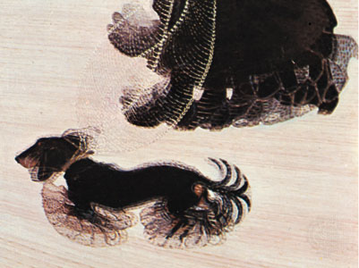
Fig1. (coll.gen. A. Conger Goodyear, New York)

Dynamism of a Dog on a Leash, oil on canvas by Giacomo Balla, 1912; in the Buffalo Fine Arts Academy, New York. Collection Albright-Knox Art Gallery, Buffalo, New York; bequest of A. Conger Goodyear and Gift of George F. Goodyear, 1964

Permanent Link:
http://www.britannica.com/EBchecked/media/8725/Dynamism-of-a-Dog-on-a-Leash-oil-on-canvas

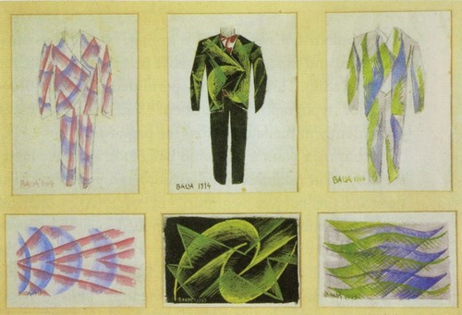
Fig.2
Illustrations made by Balla for the Anti-Neutral suit Manifesto (1914), rendered real and worn by Balla himself in 1915. The intention was to create men’s clothing that was more dynamic, colorful and asymmetrical, which broke with tradition and will make the men look more aggressive and belligerent.

Permanent Link:
http://www.futur-ism.it/collezioni/libri/libri.asp?sez=2&det=18

http://www.hirshhorn.si.edu/search-results/?edan_search_value=giacomo+balla&edan_search_button=Search+Collection#
http://www.guggenheim.org/new-york/collections/collection-online/artwork/300

